Session-1

1).Install MySQL Workbench on your computer, connect to the local MySQL server, and take a screenshot of the default databases shown in the Schemas panel.

Ans) 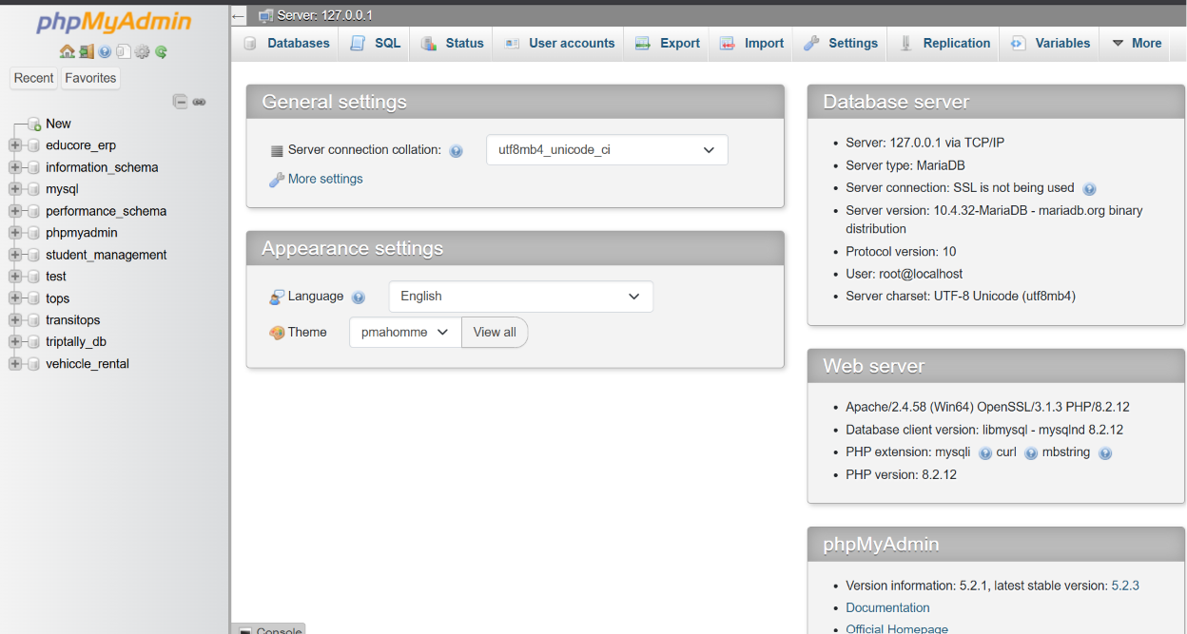

2).Create a new database called InstaClone in MySQL Workbench, then create a table named Users with columns: user_id (INT, primary key), username (VARCHAR), email (VARCHAR), and followers_count (INT).

Ans)
CREATE DATABASE InstaClone;
USE InstaClone;
CREATE TABLE Users (
user_id INT PRIMARY KEY,
username VARCHAR(50),
email VARCHAR(100),
followers_count INT
);

Output:
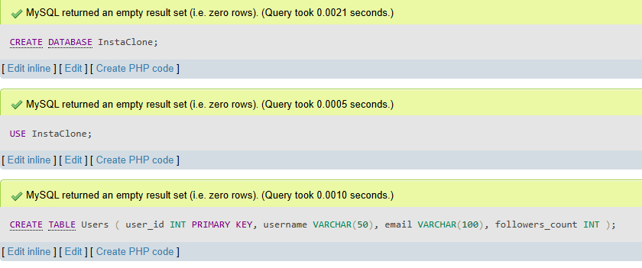

3).Insert 3 sample users into the Users table you created, using realistic Instagram-style usernames and follower counts.

Ans)
INSERT INTO Users (user_id, username, email, followers_count)
VALUES
(1, 'travel_with_om', 'om@gmail.com', 1250),
(2, 'foodie_priya', 'priya@gmail.com', 8450),
(3, 'tech_guru_raj', 'raj@gmail.com', 22300);

Output;-
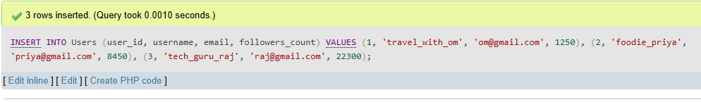

4).Create another table in the InstaClone database called Posts with columns: post_id (INT, primary key), user_id (INT), caption (VARCHAR), and post_date (DATE). Add a foreign key from Posts.user_id to Users.user_id to establish a relationship.

Ans) CREATE TABLE Posts (
post_id INT PRIMARY KEY,
user_id INT,
caption VARCHAR(255),
post_date DATE,
FOREIGN KEY (user_id) REFERENCES Users(user_id)
);

Output:-
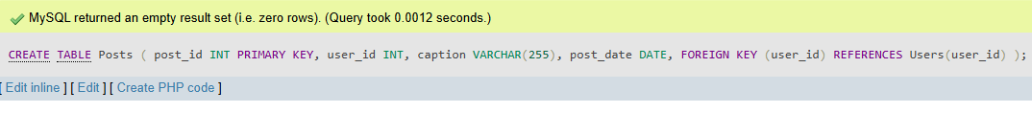

5).Write a short comparison (3-4 lines each) of MySQL, PostgreSQL, Oracle, and SQLite, focusing on where each one is commonly used (for example: web apps, mobile apps, enterprise systems, etc.).

Ans)
MySQL
MySQL is one of the most popular open-source relational database systems. It is widely used for web applications such as WordPress, Instagram-like applications, and e-commerce websites. It is fast, reliable, and easy to learn, making it suitable for beginners and small-to-medium businesses.
PostgreSQL
PostgreSQL is an advanced open-source relational database known for its powerful features and SQL compliance. It is commonly used in enterprise applications, GIS systems, financial software, and data analytics platforms. It offers excellent support for complex queries and large-scale applications.
Oracle Database
Oracle Database is a commercial relational database management system designed for enterprise environments. It is widely used by banks, government organizations, healthcare systems, and large multinational companies. Oracle provides high performance, security, scalability, and advanced backup and recovery features.
SQLite
SQLite is a lightweight, serverless relational database stored in a single file. It is commonly used in mobile applications, desktop software, IoT devices, and embedded systems. Since it requires no separate server installation, it is ideal for small applications and local data storage.

